Improving the index page
So far, we have been manually typing in the URL every time we want to see a single Fact. It would be a nicer experience if we could click on the facts from our List without having to remember the IDs for each one.
Back in browser, let’s add a few facts to work with:
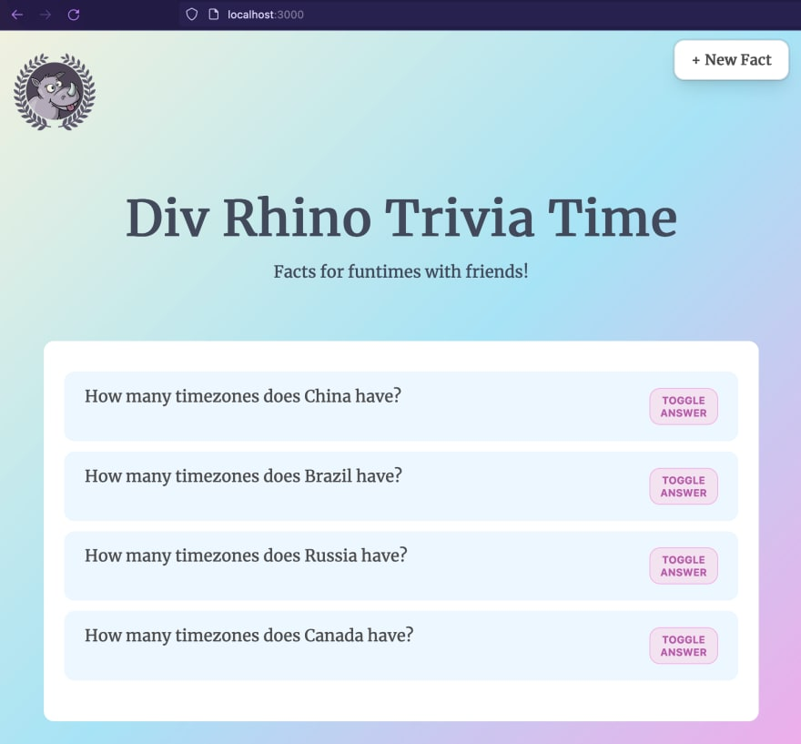
Since we have a show page now, we no longer need the toggle answer button. So we can update our index.html page to remove it. The updated markup looks like this:
<div class="container">
{{if .Facts}}
{{ range .Facts }}
<a href="/fact/{{ .ID }}">
<div class="fact-item">
<div class="question-wrapper">
<p class="question">{{ .Question }}</p>
<div class="actions">
{{template "icon-arrow-right" .}}
</div>
</div>
</div>
</a>

{{ end }}
{{else}}
<div class="no-facts">
<p>No facts yet.</p>
<p><a href="/fact">Add now</a></p>
</div>
{{end}}
</div>
We are using a new partial called icon-arrow-right, but it does not exist yet. So let’s create that now.
First let’s create a new folder to hold all our icon partials
mkdir views/icons
Then inside this new folder, let’s create our icon-arrow-right partial
touch views/icons/icon-arrow-right.html
Then within icon-arrow-right.html, we can paste some SVG code:
{{define "icon-arrow-right"}}
<svg xmlns="http://www.w3.org/2000/svg" fill="none" viewBox="0 0 24 24" stroke-width="1.5" stroke="#4b5366" width="24" height="24">
<path stroke-linecap="round" stroke-linejoin="round" d="M12.75 15l3-3m0 0l-3-3m3 3h-7.5M21 12a9 9 0 11-18 0 9 9 0 0118 0z" />
</svg>
{{end}}

If we refresh our app in the browser now, this is what it should look like
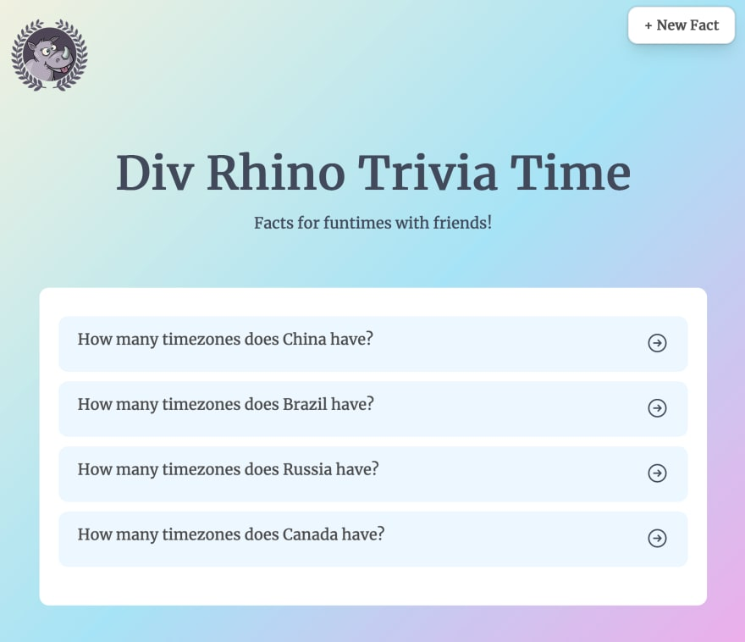
Now we can click on each fact and be taken to its individual show page where we can edit and delete it, easily.
And with that, we’ve come to the end.

Conclusion
In this tutorial we implemented all the CRUD actions - Create, Read, Update and Delete. We used JavaScript’s fetch API to make PATCH and DELETE requests. We also added a little hack to bust our browser’s cache during development.
Congratulations, you did great! Keep learning and keep coding. Bye for now,

